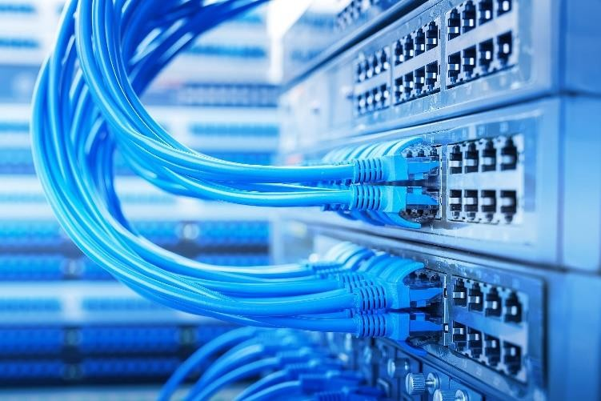

# Equipamentos Passivo e Ativo Usados em Redes

7 DE OUTUBRO

SENAI ROBERTO SIMONSEN

Criado por: Pedro Henrique Figueira

1

# SUMÁRIO

1. **Equipamentos Passivo que são utilizados na infraestrutura de Redes 3**
2. **Equipamentos Ativo que são utilizados na infraestrutura de Redes 4**

EQUIPAMENTOS PASSIVO UTILIZADOS EM REDES

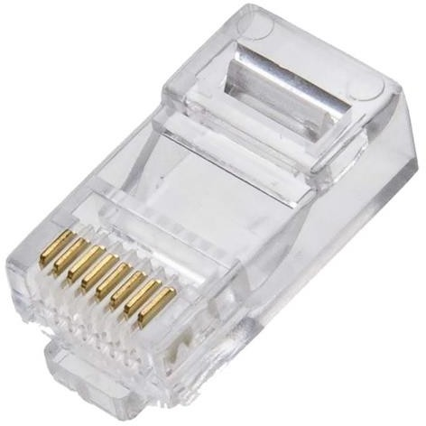

RJ45

<https://www.googleadservices.com/pagead/aclk?sa=L&ai=DChcSEwjspszD8LrzAhUEDpEKHcb_AAkYABAOGgJjZQ&ae=2&ohost=www.google.com&cid=CAASE-RoyK44maaBelU-M8wIxskS970&sig=AOD64_3M4JmmVYijuv6HbCu7cUbm2MVrlg&ctype=5&q=&ved=2ahUKEwiOrsbD8LrzAhVjH7kGHS1IDucQ9aACegQIAhBP&adurl=>

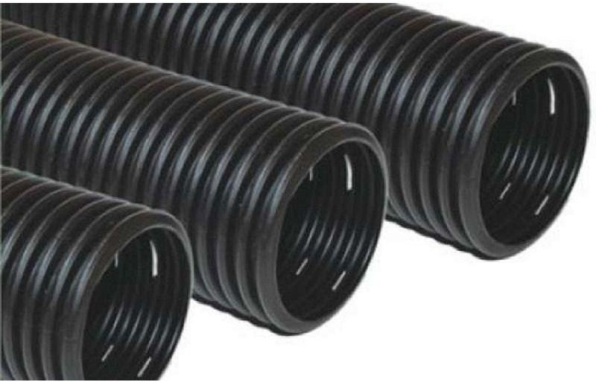

Tubo de Polietileno

<https://www.googleadservices.com/pagead/aclk?sa=L&ai=DChcSEwjEh8H58LrzAhWICpEKHUdpCKMYABAKGgJjZQ&ae=2&ohost=www.google.com&cid=CAASE-RogGS74zMdByiYU32uCAzwjjA&sig=AOD64_1gZK7R0iAOTn55RBGfXwx3QPllFQ&ctype=5&q=&ved=2ahUKEwib9br58LrzAhVILLkGHYadCUoQ9aACegQIAhBW&adurl=>

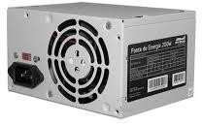

Fonte de alimentação

<https://www.kabum.com.br/produto/108178/fonte-corsair-ax-series-ax850-850w-80-plus-titanium-modular-cp-9020151-ww>

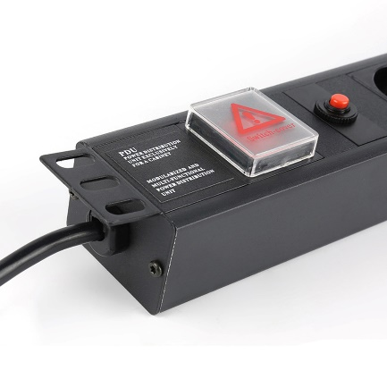Régua de distribuição alimentação

<https://pt.aliexpress.com/item/33043147936.html>

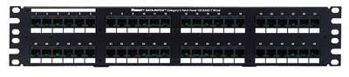

Patch panels

<https://www.google.com/aclk?sa=l&ai=DChcSEwirlsPEpbnzAhXCCJEKHctvCaIYABAEGgJjZQ&sig=AOD64_1LU3Mp_7uAQ2M5ZH_XXZX0B8LN7A&adurl&ctype=5&ved=2ahUKEwjJnLnEpbnzAhVILrkGHdFMBSQQvhd6BAgBEEc>

EQUIPAMENTOS PASSIVO UTILIZADOS EM REDES

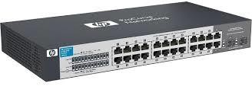

Hubs

<https://www.google.com/aclk?sa=l&ai=DChcSEwiwweqBpbnzAhWTD5EKHffMChoYABAcGgJjZQ&sig=AOD64_0v0oajL8t7KvfNX5ZPB0XLDSQklw&adurl&ctype=5&ved=2ahUKEwirz96BpbnzAhXtDLkGHUxyASMQvhd6BQgBEIUB>

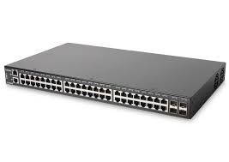Switche

<https://www.google.com/aclk?sa=l&ai=DChcSEwjv19_LornzAhWrB4gJHR_rD6IYABAHGgJxbg&sig=AOD64_1I3kRYsHtZPXbtaEiC9lCOjF4IEQ&adurl&ctype=5&ved=2ahUKEwiY-M_LornzAhV_MLkGHe_-Bn0Qvhd6BAgBEEM>

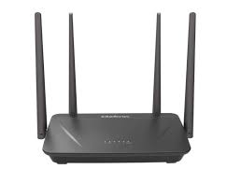Roteador

<https://www.google.com/aclk?sa=L&ai=DChcSEwimjNzbo7nzAhURuMgKHRc7DEoYABAHGgJxdQ&sig=AOD64_3wq47pjtNegoIsE4FHdHkXOdMgXw&adurl&ctype=5&ved=2ahUKEwi_scvbo7nzAhXsBNQKHVOJCEEQvhd6BAgBEF8>

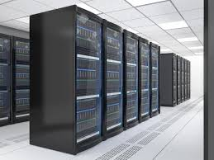 Servidores

<https://www.google.com/aclk?sa=l&ai=DChcSEwiH5s7WpLnzAhVWB5EKHYdqA80YABAFGgJjZQ&sig=AOD64_0uDBp1IYa3OPlLV40DCM8XqB6fBw&adurl&ctype=5&ved=2ahUKEwio9MHWpLnzAhWgK7kGHXNdDiEQvhd6BAgBEE0>

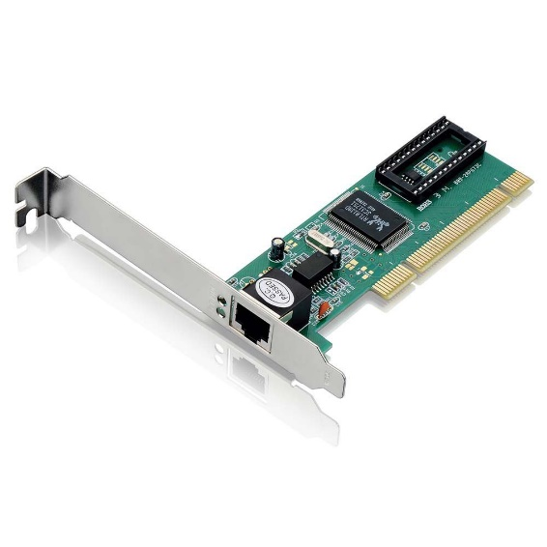Placa de rede <https://www.google.com/aclk?sa=l&ai=DChcSEwiurZ-gpLnzAhULEpEKHcC0BMYYABAHGgJjZQ&sig=AOD64_07TkW85xwD7YTpLU1xtABmSZW2JQ&adurl&ctype=5&ved=2ahUKEwjRgpOgpLnzAhVtA7kGHWYrBeUQvhd6BAgBEE0>